**COME 218**

**Programming Languages**

**Project**

**2021-2022 / Spring**

**Submission deadline: 16.6.2022**

**Instructor: Assistant Prof. Dr. Gamze Uslu**

You are required to implement a preprocessor in Java. Your preprocessor should be able to perform the following tasks on an input file, which will be a Java source file:

1. Removing comments (40 points)

Example:

Input:

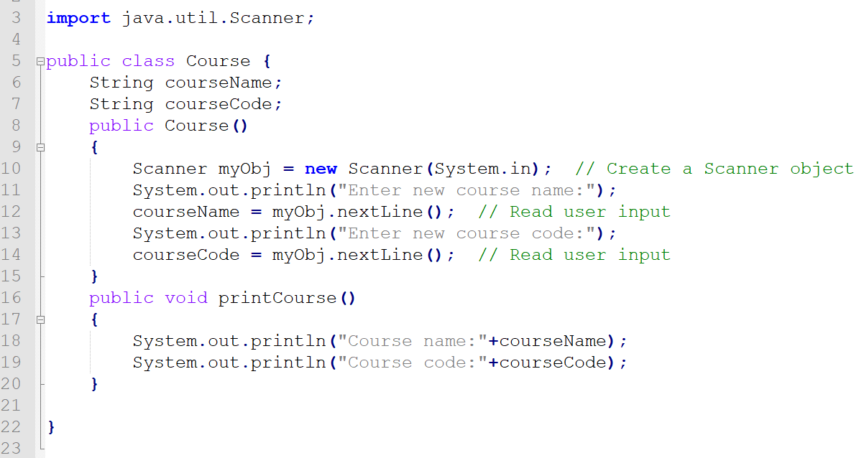

Output:

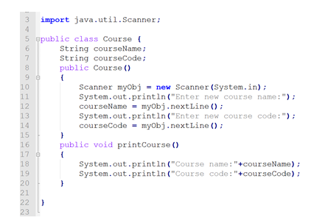

The output for this task should be written to a file.

1. Identifying built-in language constructs (30 points)

Example:

Input:



Output:

import java.util.Scanner

public

class

String

Scanner

new Scanner(System.in)

System.out.print.ln

nextLine

void

1. Identifying loops and methods (30 points)

Example:

Input:

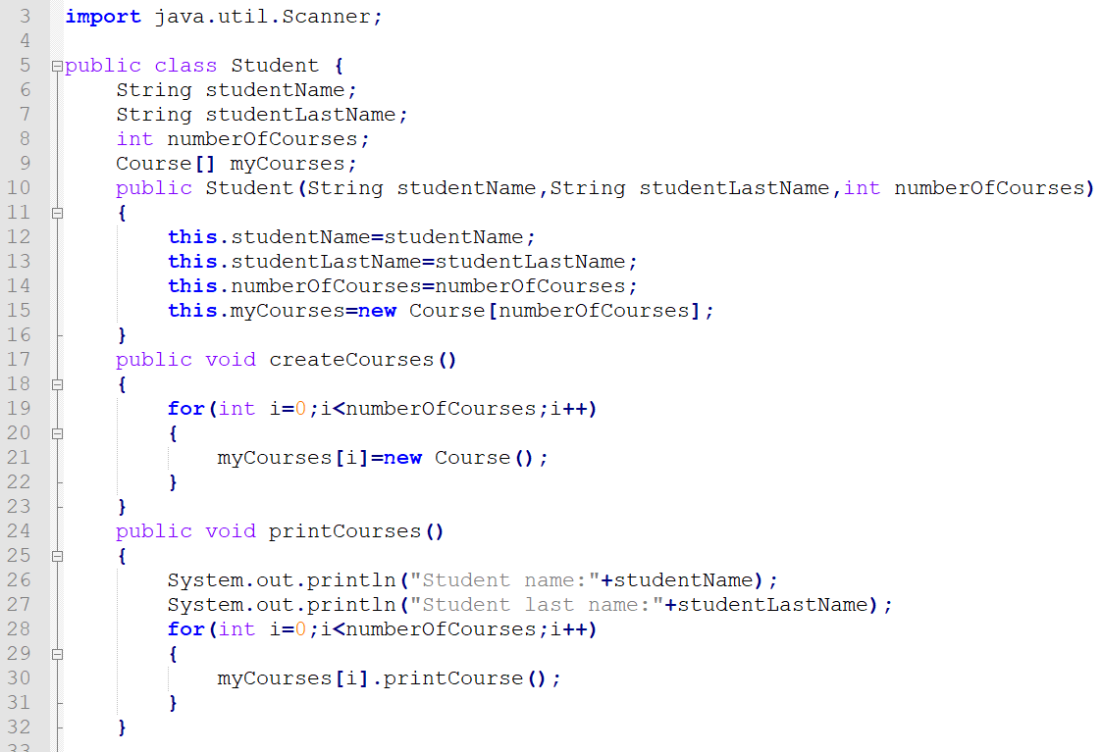

Output:

Methods:

public void createCourses() between lines 17-23

public void printCourses() between lines 24-32

Loops:

for loop between lines 19-22

for loop between lines 28-31

**Reminders:**

1. Your project should work with all inputs conforming to the rules described above. (The input files with which your project will be executed are not limited to the examples given in this file.)
2. Submit your own work. All submitted projects will go through a similarity check and your grade will be determined accordingly. For example, if the similarity report for your project yields a similarity rate of 90%, your grade will be 100-90=10 points out of 100.
3. Submit your project in a rar file. Your rar file will include your implementation, the input and output files of your project and a readme file. The readme file will contain name, last name and ID of the student.